Set up a Client with Locally:
- Contact your Wintersteiger Easyrent Support Member to check license for the Web Shop Adapter and enable Webshop Module
- Configure Webshop
  - In Easyrent Navigate to Maintenance > Webshop > Settings
  - In Stocks (OUT) Folder place path to Dropbox folder being shared with Locally
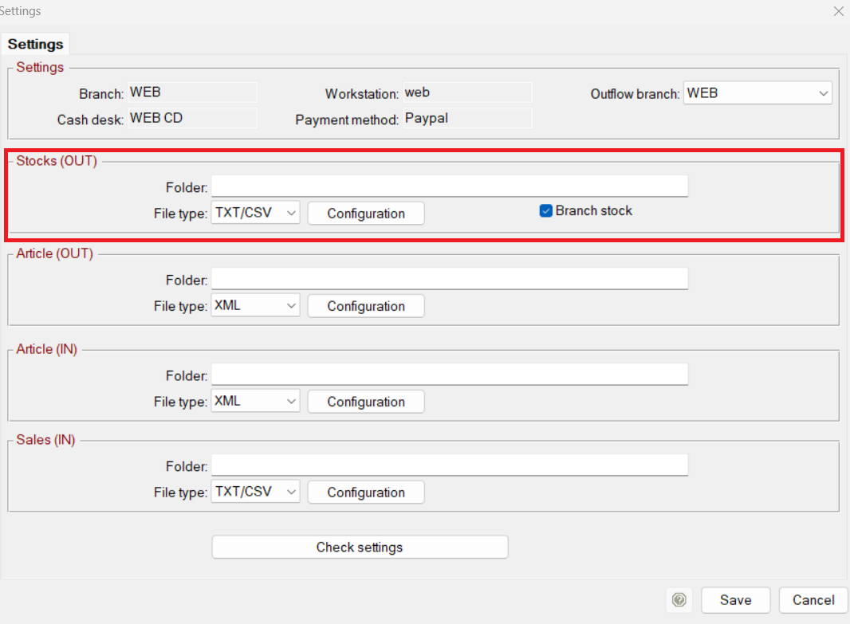
  - Select TXT/CSV in File Type Field
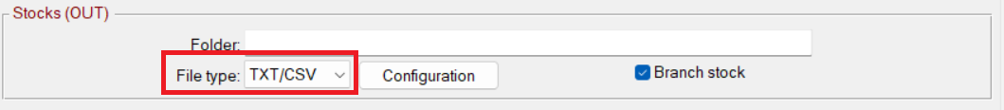
  - Click “Configuration” button and set all fields like the following:
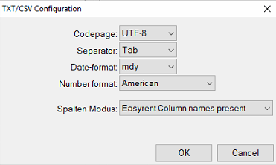
  - Check “Branch Stock” to send branch specific inventory values on the file
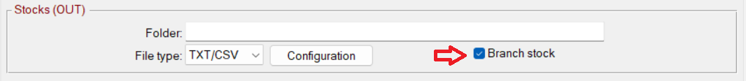
  - Hit Save, then End to save settings
- Configure Easytask to generate file on a schedule
  - Navigate to Maintenance > Easytask
  - Click “new data record” to create an additional task
  - Select “WebShop – Export Stocks” from the dropdown
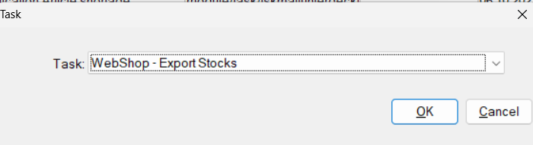
  - Hit “OK”
  - Check “Active” , Enter Duration Interval in minutes, hit “Now” so task runs Asap and generates your file, Hit “Save”

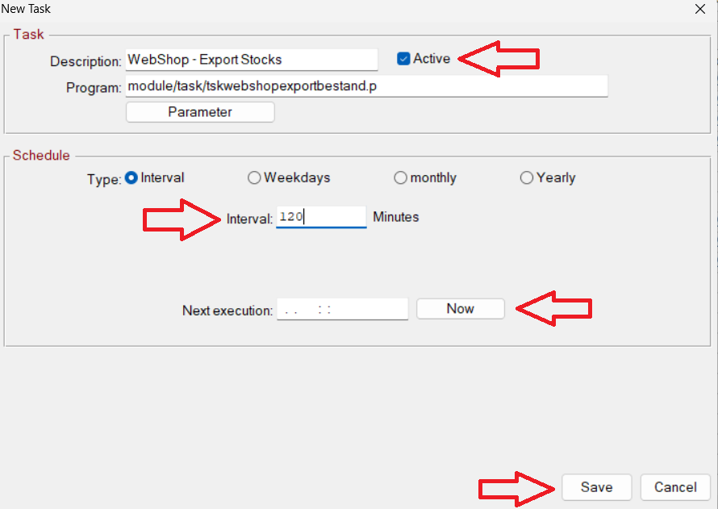

  - Check Dropbox folder location to see if file has been created.

